National University of Computer and Emerging Sciences



AL-2002: Artificial Intelligence Lab
Lab Manual 09

Department of Computer Science
FAST-NU, Lahore, Pakistan

Table of Contents
Objectives 3
1 What is Machine learning? 3
1.1 Types of Machine Learning 3
1.2 Supervised Learning 4
2 What is Scikit-learn? 5
2.1 Basic Workflow in Scikit-learn 7
3 Classification 9
3.1 Import Libraries 10
3.2 Load the Dataset 10
3.3 Split Data (Train/Test) 10
3.4 Feature Scaling 10
3.5 Train the Classifier 11
3.6 Make Predictions 11
3.7 Evaluate the Model 11
3.8 Trying Another Classifier 12
4 Regression 12
4.1 Import Libraries 12
4.2 Load the Dataset 13
4.3 Split Data (Train/Test) 13
4.4 Feature Scaling 13
4.5 Train the Regression Model 13
4.6 Make Predictions 14
4.7 Evaluate the Model 14
4.8 Trying Another Regression Model 14

Objectives
After performing this lab, students shall be able to understand the following concepts and applications:
- Use of scikitt-learn for classification and regression
- Basic model evaluation

What is Machine learning?

Machine Learning (ML) is a field of computer science that enables computers to learn patterns from data and make predictions or decisions without being explicitly programmed for each task. Instead of manually writing rules, we allow the system to learn those rules automatically from examples.

Traditional Programming

- Input data + Fixed rules = Output
- Rules are written by humans

Machine Learning

- Input data + Correct outputs = Model learns rules
- Rules are learned automatically from data

Some real world examples of machine learning include:
- Spam email detection
- Medical diagnosis
- House price prediction
- Credit card fraud detection
- Recommendation systems

Types of Machine Learning

Machine learning is generally divided into three categories:

Type | Description | Example
Supervised Learning | Data includes correct answers | Predict exam score
Unsupervised Learning | No labeled output | Customer grouping
Reinforcement Learning | Learning via rewards | Game playing AI

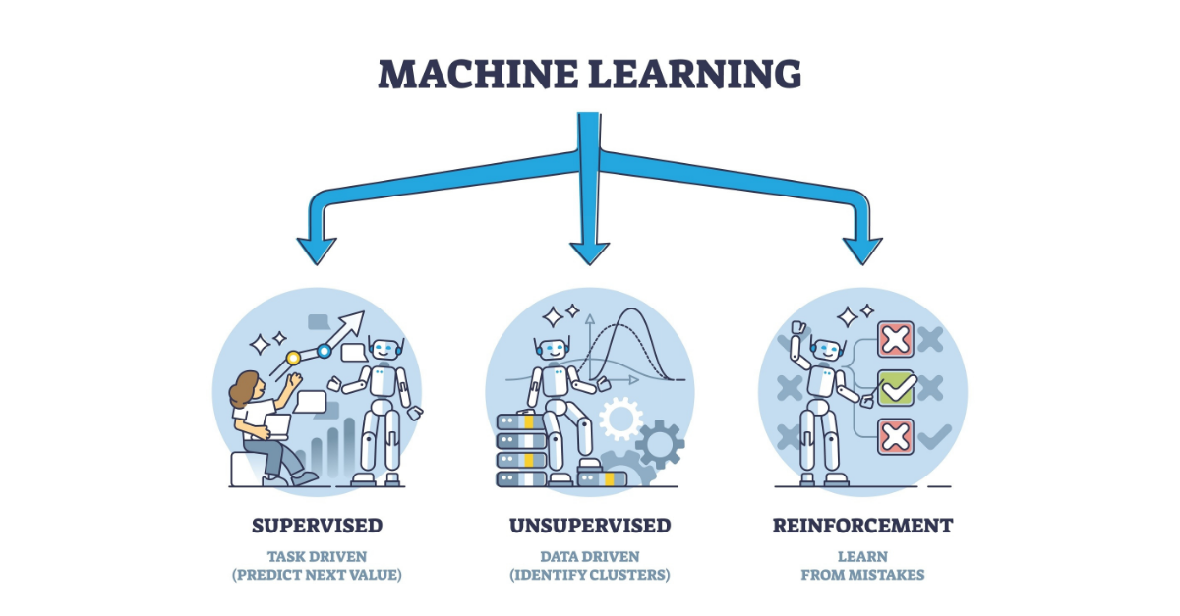

Supervised Learning

Supervised learning means that we have input variables (features): X and an output variable (target/label): y. The model learns a function:

𝑓(𝑋) = 𝑦
Key Terms

- Feature: Input variable (e.g., house size)
- Target: Output variable (e.g., house price)
- Dataset: Collection of samples
- Model: Algorithm that learns patterns
- Training: Learning from known data
- Testing: Evaluating on unseen data

Supervised learning has two main categories. Each of them is explained below.

Regression
Regression is a type of supervised learning used when the target variable is continuous. A continuous variable can take any numerical value within a range. For example, predicting house prices, estimating temperatures, forecasting sales revenue, or estimating a student’s final exam score are all regression problems.

Classification
Classification is a type of supervised learning used when the target variable is categorical. In classification problems, the goal is to assign an input example to one of several predefined classes. For example, determining whether an email is spam or not spam, predicting whether a patient has a disease or not, or classifying images of animals into categories are all classification tasks.

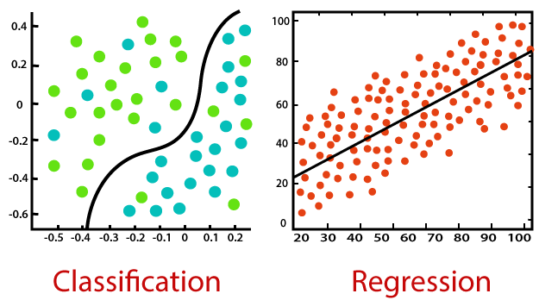

What is Scikit-learn?

Scikit-learn (also written as sklearn) is an open-source machine learning library for Python. It provides simple and efficient tools for building, training, and evaluating machine learning models.

It is built on top of:
- NumPy (numerical computation)
- Pandas (data handling)
- Matplotlib (visualization)

Before libraries like Scikit-learn, implementing machine learning algorithms required writing complex mathematical code from scratch.

With Scikit-learn, we can:
- Load datasets easily
- Preprocess data
- Train models in a few lines of code
- Evaluate performance
- Compare different algorithms

Scikit-learn supports many machine learning tasks such as:

- Supervised Learning
  - Linear Regression
  - Logistic Regression
  - K-Nearest Neighbors
  - Decision Trees
  - Random Forest
  - Support Vector Machines
- Unsupervised Learning
  - K-Means Clustering
  - Hierarchical Clustering
  - PCA (Dimensionality Reduction)
- Preprocessing Tools
  - Scaling features
  - Encoding categorical variables
  - Handling missing values
- Model Evaluation
  - Accuracy
  - Precision, Recall
  - Confusion Matrix
  - Cross-validation

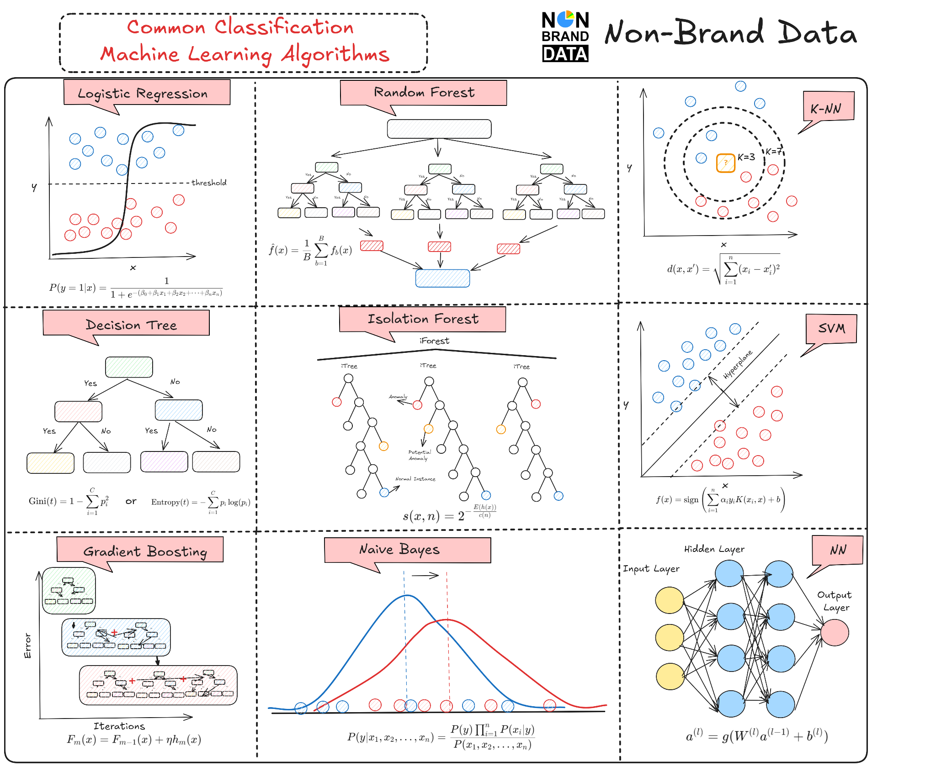

All models in Scikit-learn follow the same structure

Method | Purpose
fit() | Train the model
predict() | Make predictions
score() | Evaluate performance

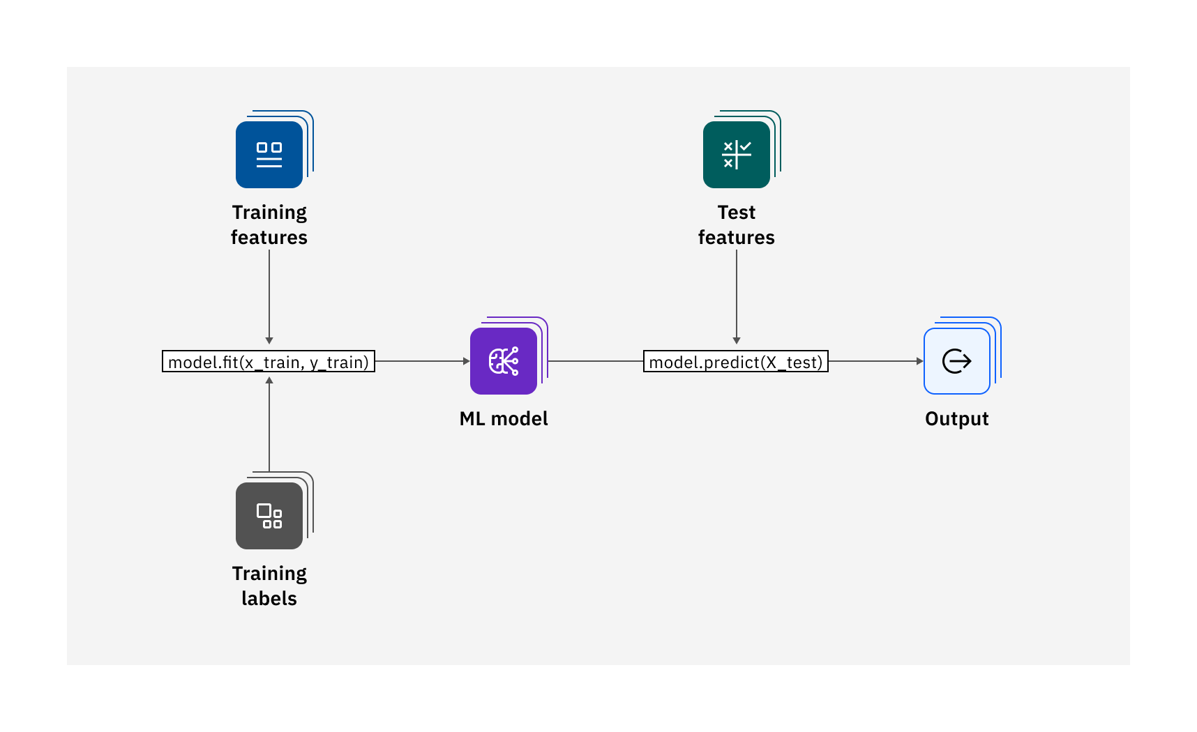

Basic Workflow in Scikit-learn

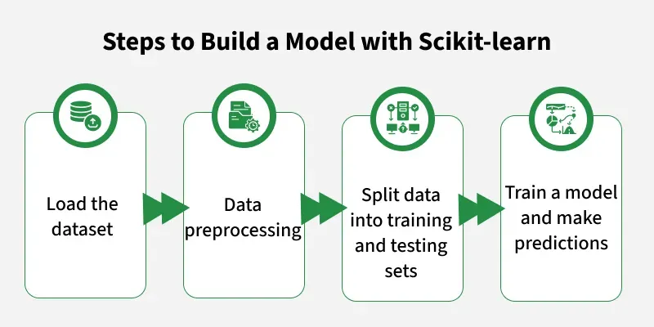

We have already covered the first 2 steps in previous labs.

Split Data (Train/Test)

In machine learning, our goal is not just to build a model that performs well on known data, but one that performs well on new, unseen data.

If we train and test the model using the same dataset, the model may memorize the data and the performance may look very high but it may fail in real-world scenarios.

To avoid this, we divide the dataset into two parts:
- Training Set: The training set is used to:
- Teach the model
- Learn patterns
- Estimate parameters (weights)
During training, the model:
- Looks at input features (X)
- Compares predictions with actual outputs (y)
- Adjusts its parameters to reduce error
- Testing Set: The testing set is used to:
- Evaluate model performance
- Measure generalization ability
- Simulate real-world prediction
The model must never learn from the test data. The test data must remain unseen during training.

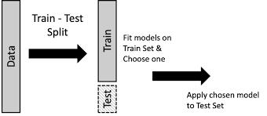
Suppose we have 100 student records. If we split 80–20:
- 80 records: Training set
- 20 records: Testing set
The model learns from the 80 students and is evaluated on the 20 new students.

from sklearn.model_selection import train_test_split

X_train, X_test, y_train, y_test = train_test_split(X, y,test_size=0.2, random_state=42)

Parameter | Meaning
X | Features
y | Target
test_size=0.2 | 20% data used for testing
random_state=42 | Ensures reproducibility
When splitting data:
- The split is random.
- Different runs may give different results.
By setting random_state=42, we ensure:
- Same split every time
- Reproducible results
- Fair comparison between models

Model Training

We will be covering 2 types of models: classification and regression.

Classification

In this section, we will go through an example of how we can train and test a classification model step by step.

Import Libraries

import numpy as np
import pandas as pd

from sklearn.datasets import load_iris
from sklearn.model_selection import train_test_split
from sklearn.preprocessing import StandardScaler
from sklearn.linear_model import LogisticRegression
from sklearn.metrics import accuracy_score, confusion_matrix, classification_report

Load the Dataset

iris = load_iris()

X = iris.data # Features
y = iris.target # Labels

print(X.shape) # (150 samples, 4 features)
print(y.shape) # (150,)

Split Data (Train/Test)

X_train, X_test, y_train, y_test = train_test_split(
X, y,
test_size=0.2,
random_state=42
)

Feature Scaling

scaler = StandardScaler()

X_train = scaler.fit_transform(X_train)
X_test = scaler.transform(X_test)

Train the Classifier

model = LogisticRegression()
model.fit(X_train, y_train)

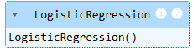

We are using logistic regression as a classifier here. You can explore other classifiers here: https://scikit-learn.org/stable/supervised_learning.html
What happens internally:
- The model learns decision boundaries
- It finds weights that best separate classes

Make Predictions

y_pred = model.predict(X_test)

Evaluate the Model

accuracy = accuracy_score(y_test, y_pred)
print("Accuracy:", accuracy)
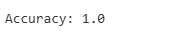
cm = confusion_matrix(y_test, y_pred)
print(cm)
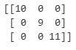

print(classification_report(y_test, y_pred))
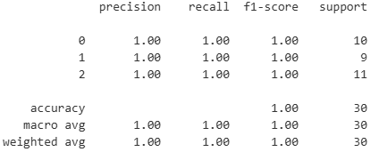

Trying Another Classifier

from sklearn.neighbors import KNeighborsClassifier

knn = KNeighborsClassifier(n_neighbors=5)
knn.fit(X_train, y_train)

y_pred_knn = knn.predict(X_test)

print("KNN Accuracy:", accuracy_score(y_test, y_pred_knn)))

Regression

In this section, we will go through an example of how we can train and test a regression model step by step.

Import Libraries

import numpy as np
import pandas as pd

from sklearn.datasets import fetch_california_housing
from sklearn.model_selection import train_test_split
from sklearn.preprocessing import StandardScaler
from sklearn.linear_model import LinearRegression
from sklearn.metrics import mean_squared_error, r2_score

Load the Dataset

data = fetch_california_housing()

X = data.data # Features
y = data.target # Target

print(X.shape) # (20640 samples, 8 features)
print(y.shape) # (20640,)

Split Data (Train/Test)

X_train, X_test, y_train, y_test = train_test_split(
X, y,
test_size=0.2,
random_state=42
)

Feature Scaling

scaler = StandardScaler()

X_train = scaler.fit_transform(X_train)
X_test = scaler.transform(X_test)

Train the Regression Model

model = LinearRegression()
model.fit(X_train, y_train)

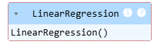

We are using linear regression as a regressor here. You can explore other regressors here: https://scikit-learn.org/stable/supervised_learning.html
What happens internally:
- Model finds weights for each feature
- Minimizes the difference between predicted and actual values

Make Predictions

y_pred = model.predict(X_test)

Evaluate the Model

mse = mean_squared_error(y_test, y_pred)
print("MSE:", mse)
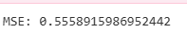
rmse = np.sqrt(mse)
print("RMSE:", rmse)
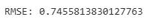

r2 = r2_score(y_test, y_pred)
print("R² Score:", r2)
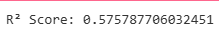

Trying Another Regression Model

from sklearn.tree import DecisionTreeRegressor

tree_model = DecisionTreeRegressor(random_state=42)
tree_model.fit(X_train, y_train)

y_pred_tree = tree_model.predict(X_test)

print("Decision Tree R² Score:", r2_score(y_test, y_pred_tree))
EXERCISE QUESTIONS:
Question 1 — Student Performance Prediction (Classification)
A university wants to predict whether a student will Pass or Fail based on:
- Study Hours
- Attendance (%)
- Assignment Score
- Previous GPA
Tasks
- Create a dataset manually (at least 20 records)
- Split data into training and testing sets (80-20 split)
- Apply feature scaling
- Train a Logistic Regression model
- Make predictions on test data
- Evaluate using:
  - Accuracy
  - Confusion Matrix
  - Classification Report
Expected Outcome
Predict whether a new student will Pass or Fail
----------------------
Question 2 — Email Spam Detection (Classification)
A company wants to detect whether an email is Spam or Not Spam.
Dataset features:
- Email Length
- Number of Links
- Number of Special Characters
- Contains "Free" (Yes/No)
Tasks
- Create dataset manually (minimum 20 rows)
- Split dataset into train and test
- Train K-Nearest Neighbors (KNN) classifier
- Make predictions
- Compare results with Logistic Regression
- Print accuracy of both models
Expected Outcome
Compare which model performs better:
- Logistic Regression
- KNN
----------------------
Question 3 — House Price Prediction (Regression)
A real estate company wants to predict house price based on:
- House Size (sq ft)
- Number of Rooms
- Location Score
- Age of House
Tasks
- Create dataset (20-30 records)
- Split data (80-20)
- Apply feature scaling
- Train Linear Regression model
- Make predictions
- Evaluate using:
  - MSE
  - RMSE
  - R² Score
----------------------
Question 4 — Employee Salary Prediction (Regression)
A company wants to predict employee salary based on:
- Years of Experience
- Education Level
- Skill Score
- Age
Tasks
- Create dataset (minimum 25 records)
- Split dataset
- Train Linear Regression
- Train Decision Tree Regressor
- Compare R² score of both models
- Identify best model
----------------------
Question 5 — Customer Purchase Prediction (Classification)
An online store wants to predict whether a customer will Buy or Not Buy.
Features:
- Age
- Income
- Previous Purchases
- Time Spent on Website
Tasks
- Create dataset manually
- Split data
- Apply feature scaling
- Train:
  - Logistic Regression
  - KNN
- Compare accuracy
- Predict new customer behavior

